Participant Handbook

MIT Hacking Medicine Boston Grand Hack 2026
March 13 - 15th, 2026

Schedule
Workshops
Arrival
Resources
Tracks
Pitch Decks
Help Desk
Sponsor Hall
Event Details
On-Site Logistics
Parking
Judging
Prizes

Schedule
All times below are Eastern. The Media Lab will be the primary site of Grand Hack, located at 75 Amherst St, Cambridge, MA 02139 (Building E14).

Day | Time | Location | Event
Thursday | Programming for Golden Ticket winners and Beyond Hack participants.
Friday | 4:00 PM | Media Lab - Lobby | Check-in Begins
 | 5:00 PM | Media Lab - MPR | Event kickoff - Opening Presentations
 | 6:00 PM | Media Lab | Problem Pitching
 | 7:00 PM | Media Lab | Dinner
 | 8:00 PM | Media Lab | Team Formation
 | 10:00 PM | Media Lab | End of Friday Hacking
Saturday | 8:30 AM | Media Lab | - Breakfast  - Begin hacking!  - Continued Team Formation
 | 9:00 AM | Media Lab | Kickoff
 | 9:30 AM - 3:00 PM | Media Lab | - Continued hacking  - Hacking workshops
 | 12:00 PM | Media Lab | - Team Registration Due  - Lunch
(ongoing) | 1:00 PM | Media Lab | - Continued hacking
 | 6:00 PM | Media Lab | Dinner
 | 7:00 PM | Media Lab | Practice pitches
 | 10:00 PM | Media Lab | End of Saturday hacking
Sunday | 8:30 AM | Media Lab | - Breakfast  - Resume hacking
 | 9:00 AM | Media Lab | Kickoff
 | 9:15 - 11:00 AM | Media Lab | Practice pitches + feedback
 | 12:00 PM | Media Lab | - Final Presentation Due  - Lunch
 | 1:00 PM | Media Lab - MPR | Final presentations
 | 3:00 PM | Media Lab - MPR | Beyond Hack Presentations
 | 4:15 PM | Media Lab - MPR | Awards ceremony
 | 5:00 PM | Media Lab | Hackathon ends

Workshops
We have a number of workshops happening on Saturday covering a variety of topics across tracks. Our sponsors have invited industry experts to discuss some of the most pressing healthcare problems in their fields and to provide guidance on how to address these problems. We hope that these talks will help you develop your projects and inspire you to tackle new challenges!

All times below are Eastern.
Day | Time | Location | Event
 | 10:30-11:30 AM | Lecture Hall | InterSystems  Learn to use the InterSystems IRIS data platform, which now supports Vector Search. Use Python / SQL / Langchain / Llamaindex to easily search your data with the power of embedding models, and build RAG (retrieval-augmented generation) on your data. RAG architecture is rapidly emerging as the primary way to overcome the limitations of large language models (LLM), such as stale data, token limits, and hallucinations.  NOTE: this workshop is highly recommended for all participants who plan to compete in the InterSystems challenge
 | 11:30-12:00 PM | Lecture Hall | Prototyping Safety and Information  NOTE: this workshop is required for all participants who plan to take advantage of prototyping and use the Makerspace.
 | 1:00-1:45 PM | Lecture Hall | How to Pitch  A session on how to pitch effectively by MIT Hacking Medicine’s Faculty Director and seasoned entrepreneur Zen Chu

Arrival
Please arrive for check-in at MIT Media Lab at 4:00 pm ET on Friday, March 13th. Our team will be waiting for you at the front desk for registration.

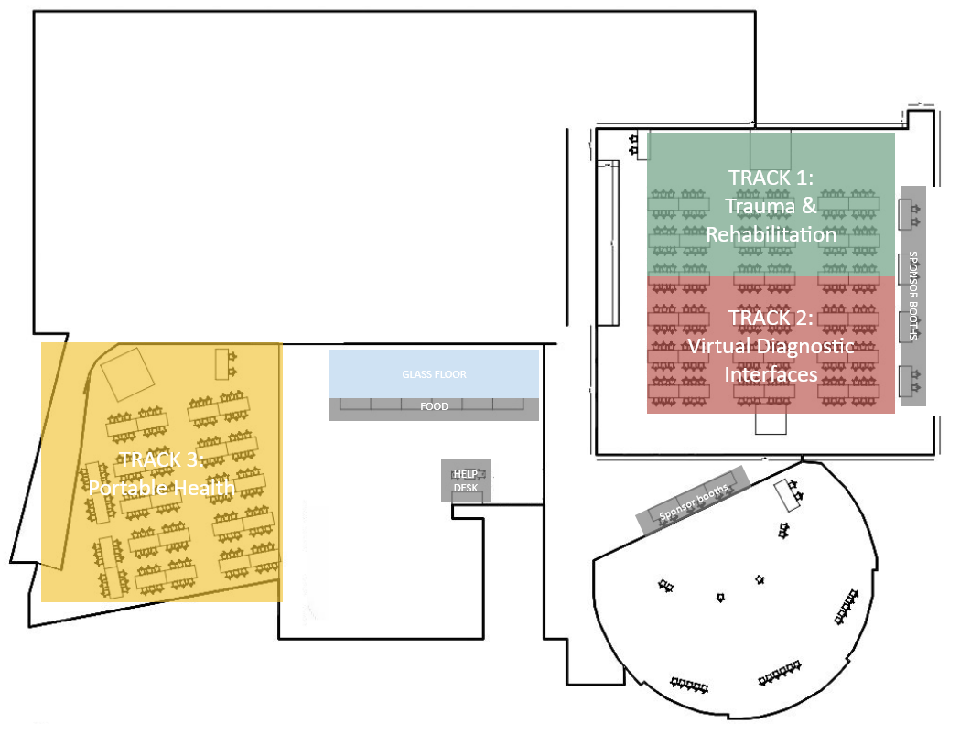

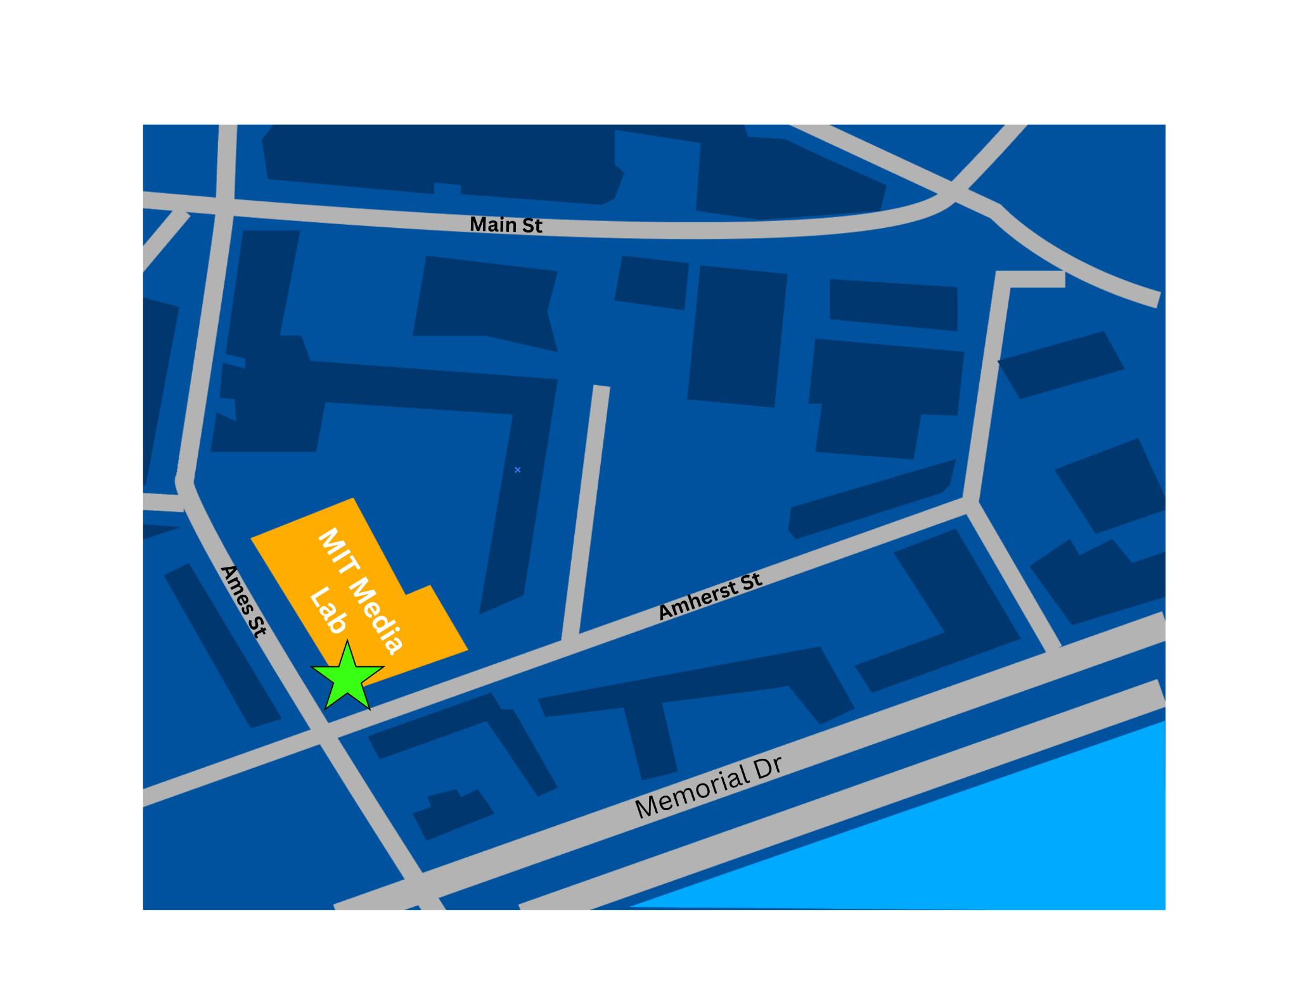

MIT Media Lab: 75 Amherst St, Cambridge, MA 02139 (Entrance indicated by star)

Resources
Prototyping Materials: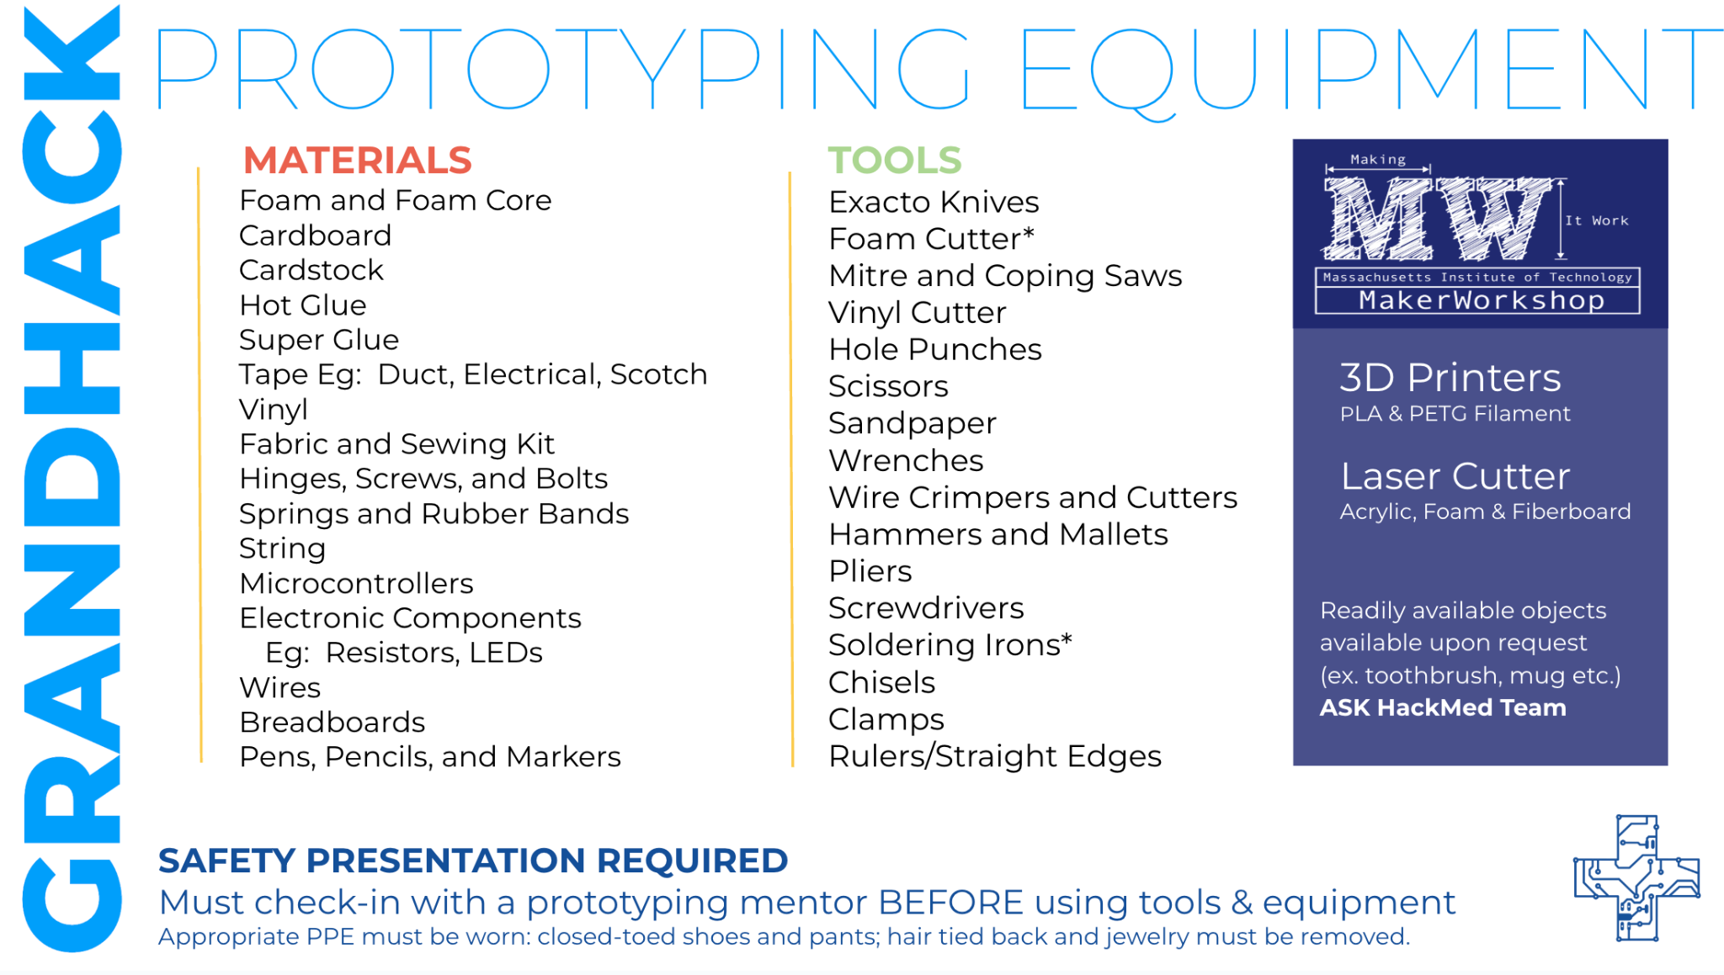

Mentor Queue:
The Mentor Queue is how teams can connect with mentors during the event. The Queue can be accessed at mithackmed.live upon logging in.

The Queue will begin accepting tickets on Saturday at 9:00 AM on the live event website. You can meet the mentors for GrandHack 2026 on the website as well by navigating to the mentors tab. More instructions can be found here: Mentor Queue Instructions.

Grandhack FAQs: FAQ Page__BOS 2026

Grandhack Website: https://hackingmedicine.mit.edu/events/grandhack-2026

Slack Community:
A Slack workspace is being created where you can connect with other participants. Please find the #travel-and-housing channel to discuss accommodations, cost-sharing, airbnb sharing and other potential hosting options. You can expect to receive an invitation to join this Slack workspace by the end of February. Please check your spam and junk folders if you do not see the email.
If you didn’t receive the Slack invitation email, you can join directly using this link.
(Make sure to use the same email as your application to avoid delays or mix-ups)
Announcements: Announcements will be made through Slack

Financial Aid Resources: Resources

Social Media Resources: PNGs – link, Canva – link

Tracks

Track 1: Trauma & Rehabilitation (TR)

Every year, millions of people experience injuries or health conditions that change how they move, live, and connect with others. Around 2.4 billion people worldwide are living with conditions that could benefit from rehabilitation, yet many still lack access to proper care and support.¹ This track invites innovators to design practical, human-centered solutions that help people recover and regain independence. From adaptive therapy tools and smart prosthetics to virtual rehab programs and home-based recovery systems, participants can explore new ways to make rehabilitation more accessible and continuous. The goal is to restore mobility, confidence, and quality of life for people on their journey to healing.

Track 2: Virtual Diagnostic Interfaces (VDI)
Accurate and timely diagnosis can make the difference between recovery and complication, yet millions still face long waits, limited access, or errors in the process. Studies estimate that diagnostic errors affect about one in twenty adults each year in outpatient settings.² This track challenges innovators to develop connected, easy-to-use diagnostic tools that bring clarity and speed to care. From AI-powered triage systems and virtual imaging platforms to symptom-checking interfaces and telehealth dashboards, participants can create technologies that help providers make faster and more confident decisions. The goal is to make diagnosis more accurate, accessible, and human for everyone.

Track 3: Portable Health (PH)
Access to care should not depend on where someone lives, yet geography remains one of the biggest barriers to healthcare. The World Health Organization estimates that around 4.5 billion people, more than half of the global population, lack access to essential health services, with rural and remote communities most affected.³ This track calls on innovators to design portable and connected health solutions that bring care to people wherever they are. From handheld diagnostics and smart sensors to smartphone-linked monitors and mobile clinics, portable health technologies can help detect illness earlier and make care more continuous. The goal is to make healthcare mobile, inclusive, and within reach for everyone.

Pitch Decks

After forming your team, the team leader will register your team with the track leads. The track leads will provide you with a pitch deck. Please make sure all your changes are updated in these decks by the final deadline.

Help Desk

The Help Desk will be located in the Wintergarden room on the Media Lab, and will be staffed for the majority of the weekend by our team. This is also where you can pick up physical resources such as whiteboards and markers. If you have any questions, come to the help desk and we will do our best to answer your questions or direct you to resources.

Sponsor Hall

Event sponsors will have booths lining the interior of the Multi-Purpose Room of the Media Lab.

Event Details

Problem Pitching
Problem pitching will occur on Friday night within each of the three tracks. All participants within a track will be able to pitch a problem that they are interested in (or multiple problems!). Each pitch will last for 45 seconds. Listen to announcements for where to go for your track.

Team Formation
Following problem pitching, participants will be given the opportunity to have discussions associated with each pitch, and will be able to form teams of 4-6 people.

Note: You do not need to stick to the problem you pitched – you’re welcome to solve another problem that was pitched or an entirely new problem altogether.

Team registration will close at noon on Saturday, though we highly encourage you to form teams before then!

Pulse Checks
Pulse checks will occur on Saturday afternoon, as a way for the organizing team to check in and see how teams are doing. Members of our team will come around to ask members of your team a series of questions about your project, so be prepared to tell us about the problem you want to address.

Practice Pitches

Practice pitches will take place on Saturday evening and Sunday morning. On Saturday, teams will have 10 minutes to meet with members of the MIT Hacking Medicine team to review their projects. You will have 5 minutes to give your pitch, and our team will spend the remaining time providing feedback on areas for improvement. On Sunday, teams will give a 3-minute pitch, which reflects the final presentation time. Please check the practice pitch sign-up sheet and stay tuned for announcements regarding your practice pitch location.

These spreadsheets will open at 1:00 PM on Saturday! When signing up for a slot, please do not overwrite another team’s entry. If you are unable to make any of the slots that are remaining, please reach out to your track lead for assistance.

Final Pitches
Final pitches will occur live on Sunday afternoon. Teams will be given exactly 3 minutes to give their pitch using their slidedeck before moving on to a 2 minute Q&A session with the judges.

Please ensure to finish all your slides before 12:00 PM ET using the pitch deck link corresponding to your team. Make sure you make the changes in the provided Google Slides link, or we cannot guarantee the slides will be in the correct format for the final presentation. The order of presentations will be random, so please do not ask ahead of time when you will present.

On-Site Logistics
Building
The building you will need to access is MIT Media Lab (75 Amherst Street), where the primary event will take place. Below, you can find an annotated map of the 6th Floor.

Parking
For those driving to campus, there are parking garages located around Cambridge and Boston. The 4 parking garages closest to the event are listed below. These garages are not affiliated with the Grand Hack.
- 33 Broadway Parking - 33 Broadway, Cambridge, MA 02142
- Kendall Center Green Garage - 355 Main St, Cambridge, MA 02142
- Kendall Center Yellow Garage - 75 Ames St, Cambridge, MA 02142
- One Kendall Square Garage - 389 Binney St, Cambridge, MA 02139

Judging

Pitches will be judged on the following criteria.
IMPACT | - Real problem  - Potential for widespread impact  - Solution addresses identified problem
INNOVATION | - Convincing rationale for why solution will work  - Addresses challenges specific to stakeholders  - Considers user experience, interface, and service design
BUSINESS MODEL | - Demonstrates a plan to work in the field  - Sustainable business model
PRESENTATION | - Presentation effectiveness  - Team (diversity backgrounds, technical expertise, etc.)

Prizes
The top three teams from each track will be awarded the following prizes

Track | 1st Place | 2nd Place | 3rd Place
1. Trauma and Rehabilitation | $2000 | $1500 | $1000
2. Virtual Diagnostic Interfaces | $2000 | $1500 | $1000
3. Portable Health | $2000 | $1500 | $1000

Prizes are distributed amongst members of your team. Information will be collected after the award ceremony. If you are not present, information must be submitted via email by May 6th, 2026 to receive the award.
**Please be aware that in the US, this amount is considered taxable income. For international recipients, MIT will apply a 30% tax rate.***

